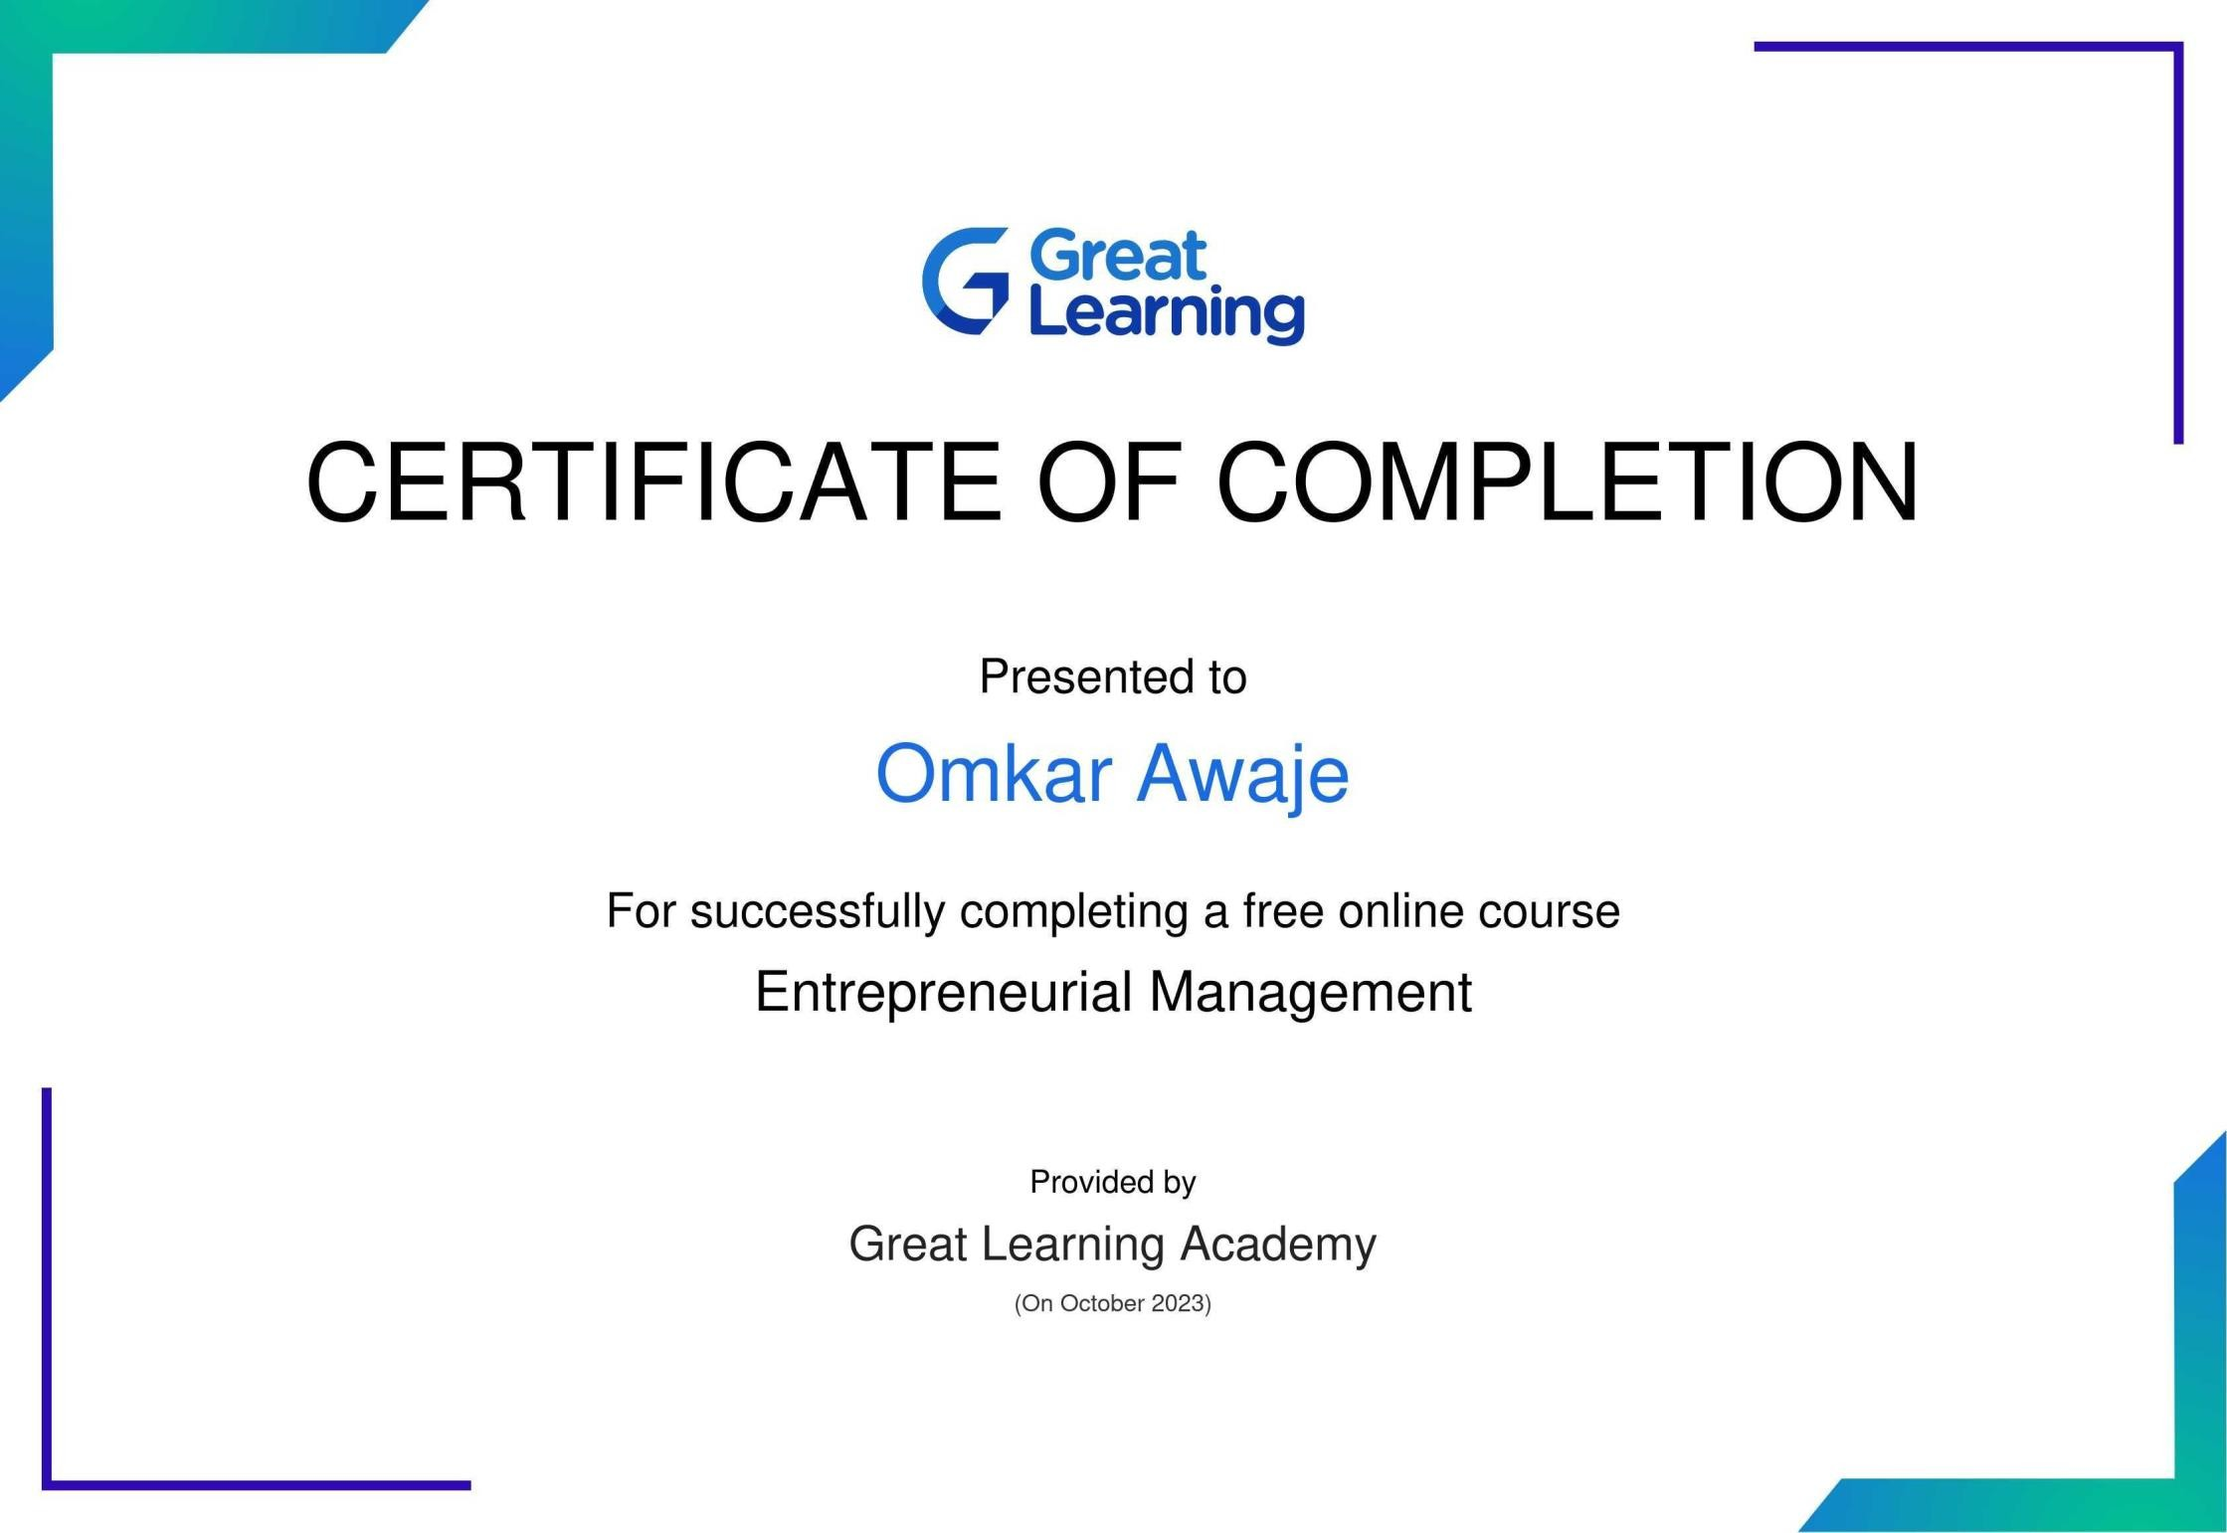

Vinayak Jamadar

To verify this certificate visit verify.mygreatlearning.com/IZMJXNZD